

DELIVERABLE 01

Group 15

Email: [capsulefy.communications@gmail.com](mailto:capsulefy.communications@gmail.com)

Website: https://capsulefy01.herokuapp.com

Cantón Fernández, Adrián

Carpio Camacho, Daniel

Fresno Aranda, Rafael

Rebollo Lobo, Pablo

Rodríguez Regidor, Juan

Index

Business Idea 2

Development team 2

Minimum Viable Product 3

Development planning 6

Technology Stack 8

Application Lifecycle Management 8

Viability study 10

Pilot users 12

Competitors analysis 13

Innovation 13

SWOT ANALYSIS 14

Strengths 14

Weaknesses 14

Opportunities 14

Threats 14

Cost estimation 14

Risk analysis 16

Pricing 17

Profit estimation 17

Conclusions 19

# Business Idea

Capsulefy is an online time capsule that allows users to create an instance in our website and store their memories inside it by uploading text and files such as images and videos and select an opening date so they can be shared in the future. One of the main focus of our product is to allow users to leave a message or their memories behind in case they pass away, and for this reason, users will be able to set a timer that they can reset by periodically logging in. In case this timer expires, the capsule will be released.

Furthermore, our product offers extra features such as connect time capsules to the user’s social networks accounts in order to publish a message when a capsule is released, share the capsules via email, making them private so that only people with an access link can display its contents. Users will also be able to create capsules with different modules whose content may be released gradually at different dates.

The main source of income of this business will be charging the users who rent a time capsule. We are offering a service and users of this service will be our clients. However, a free version with more limited features will also be available.

We think people will want to use our services because it caters to needs generated by this new digital era, such as notifying the defunction of a person to their online contacts and sharing memories with them. Besides, its range of customization feature allows the customer to use these capsules in multiple ways, such as leaving messages for their future selves, friends, or their own children.

# Development team

Our team is composed by five members, each one with different roles and responsibilities:

* Pablo Rebollo Lobo. His roles are project manager and backend developer. His main technological competencies are Spring, Django and PHP.
* Adrián Cantón Fernández, whose roles are business manager and full-stack developer. His main technological competencies are Django, Java and Bootstrap.
* Daniel Carpio Camacho, analyst and frontend developer. His main technological competencies are Django, Javascript and Bootstrap.
* Juan Rodríguez Regidor, whose roles are requirements engineer and backend developer. His competencies are Django, Python and Bootstrap.
* Rafael Fresno Aranda. His role is backend developer and will also be in charge of the interaction of our product with other applications. His main technological competencies are Node.js, Django and PHP.

Our commitment as a team is to develop our business idea in order to create a minimum viable product in a good enough state so that it can receive appropriate feedback to decide whether or not release the full version to the market and apply that feedback to improve our product.

To reach this goal, we are compromised to meet the deadlines, listen to the feedback and cooperate within the team so that we can provide a product that meets our quality standards.

# Minimum Viable Product

The functional requirements of our product are the following:

* There will be three kinds of actors: Authenticated users, guests (users who are not registered) and administrators. The system must store the username and email of the authenticated users.
* Guests must be able to list all the capsules that have been made public.
* Guests must be able to search public capsules by their creator, publication date or words contained inside its message.
* Our product will be composed of three types of capsules: Free capsules, Premium capsules and Modular capsules. Which will be created by the users. The system must store the following information about a capsule: Its creator, a title, a description, a release date and some optional attached files such as images or videos.
* An authenticated user must be able to create free capsules and pay for a Premium or Modular capsule.
* An authenticated user will be able to list and edit capsules he has created. A capsule can’t be edited after its release date.
* Free capsules will be made public to all users whether they are registered or not after its release. When it reaches its release date, his creator will be notified by email. The creator can also input a list of emails of people who he wants to notify of the capsule opening. The user can also choose to connect a capsule with his Facebook or Twitter account so that a message notifying of the opening of the capsule is automatically published on these social networks. The opening date for these capsules can be set up to one year in the future, and once they are released, they will be displayed for 6 months before disappearing.
* Premium capsules have all the features a Free capsule has plus the option of making them privates, in which case they won’t be displayed when listing or searching for capsules and can only be accessed through an url that will be shared by email. This capsule also has the option of setting up a deadman switch: If after a certain period of time the owner of the capsule has not logged in and reset the timer, the capsule will be released regardless of its scheduled release date. The owner of the capsule can decide how often this check will be made. Released capsules will be available in the system up to one year after the user’s license has expired.
* A modular capsule works as a Premium capsule but can be split into different modules, each of which can be set up to be released at a different date.
* Authenticated users must be able to recover their password by receiving a password recuperation email to the email account used to register to the site.
* A user must be able to delete his capsules anytime. He won’t have to keep paying for deleted premium or modular capsules.
* Administrators will be able to ban registered user.

In order to create a minimum viable product taking into account the requirements of the full application, a series of use cases considered as the core of our application will be implemented:

* Any actor of the system will be able to list public capsules and search them by owner, release date or keywords.
* An authenticated user will be able to create, edit and delete a free time capsule.
* An authenticated user will be able to create, edit and delete a premium time capsule.
* An authenticated user will be able to create, edit and delete a modular time capsule.
* An authenticated user will be able to set his created capsules to private and select who to share its url with as long as the capsule is not free.
* An authenticated actor who has set a deadman timer for one of his capsules will be able to reset it and modify the interval between each check.
* Alternatively, a capsule whose deadman timer reaches zero, must be released

The goal of the following images is to show some mockups of how these use cases will look like once we have developed our MVP.

The full mockups can be found at <https://marvelapp.com/4395g15/screen/53795517>

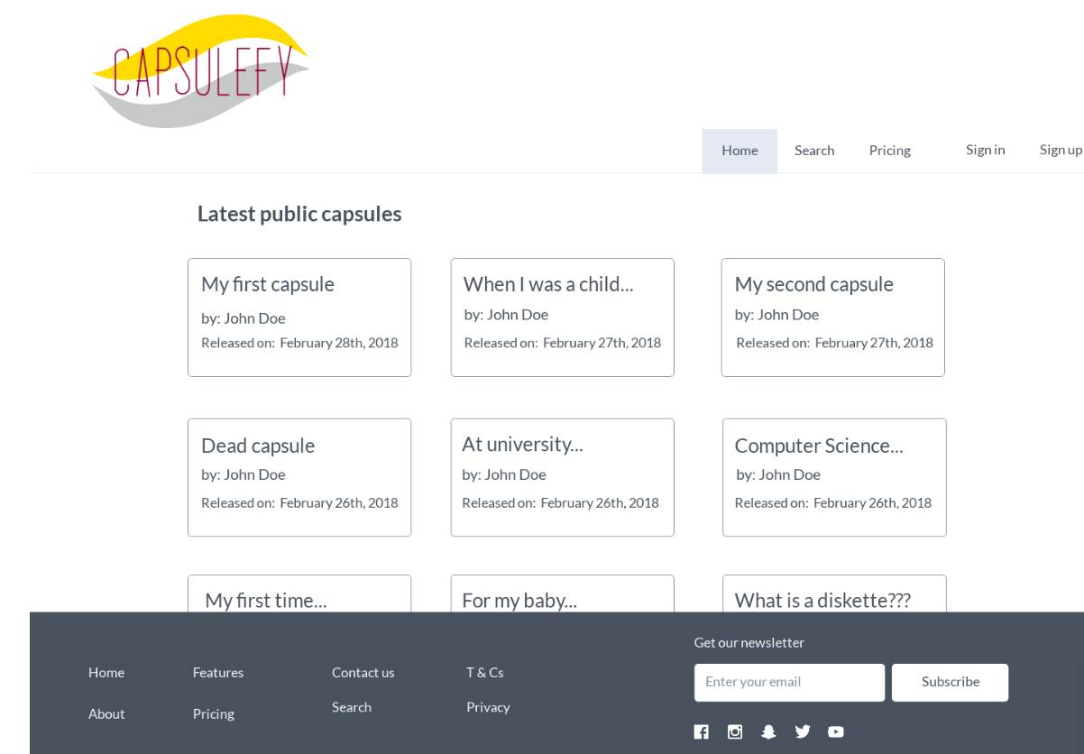

Listing public capsules

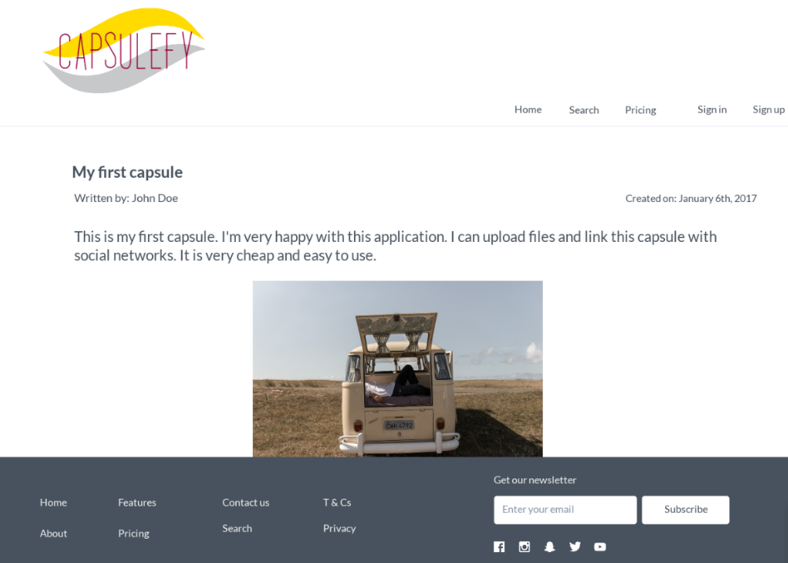

Displaying a capsule

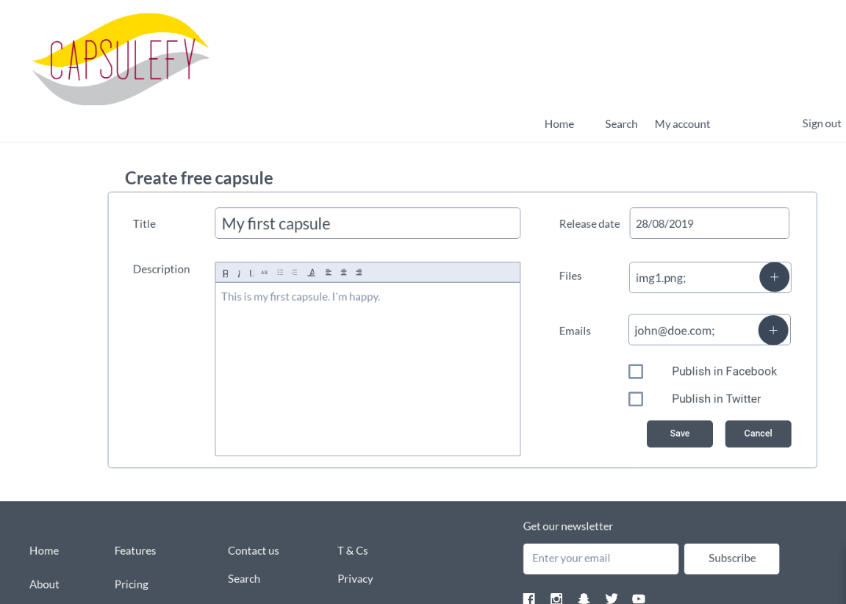

Creating a free capsule

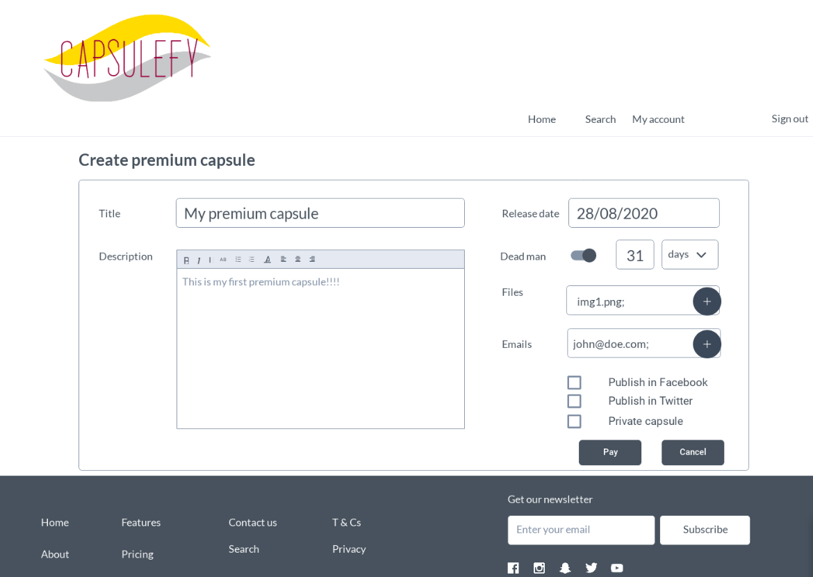

Creating a premium capsule

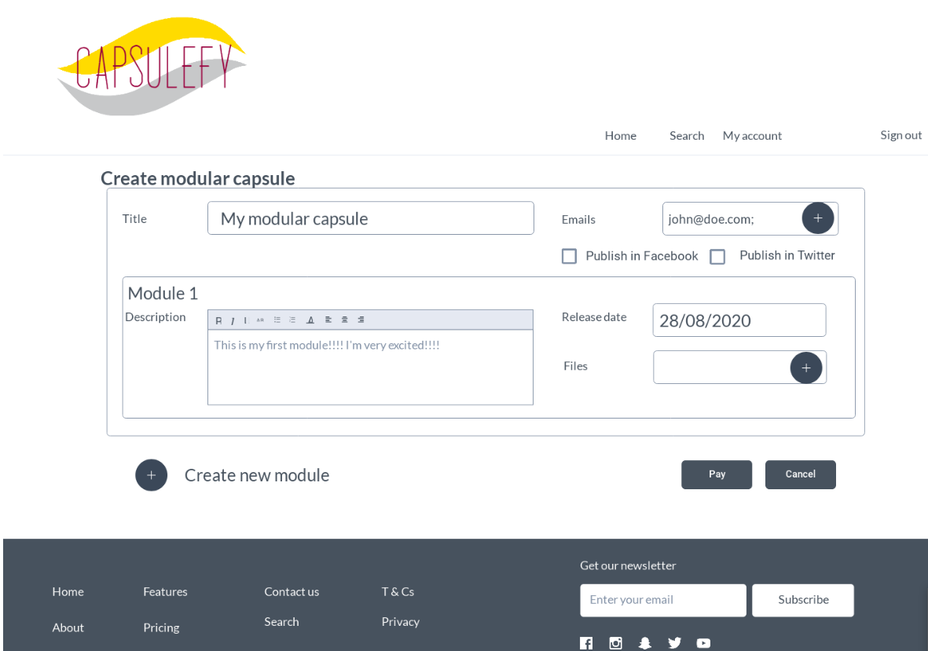

Creating a modular capsule

# Development planning

We will develop our product following the SCRUM methodology. The development of our prototype will be split into three sprints. The results generated from each sprint will be the following:

* Sprint 1: Prototype with working core use cases and a piloting plan in order to start gathering feedback.
* Sprint 2. Full working MVP. This means that not only the core use cases will be implemented, but also the payment module, the registration module and the basic admin will be working. The core use cases may be to need adapted according to the feedback resulting from the previous sprint.
* Sprint 3: Polished MVP which will take into account all the feedback from previous sprints.

Our team has a concrete planning on the tasks for the first sprint. Although it is still subject to changes, they will probably be minor tweaks, and the general structure of the sprint will remain unchanged:

|  |  |  |  |  |  |  |  |
| --- | --- | --- | --- | --- | --- | --- | --- |
| Sprint 1 | Group members | | | | | | |
| Week | Adrián Cantón | Daniel Carpio | | Juan Rodríguez | | Pablo Rebollo | Rafael Fresno |
| March 18-22 | Design of the data model. 2hx3 | | | | |  | |
| Setting up the development environment 0,5hx5 | | | | | | |
|  | | Front end design, user interface  1hx1 | |  | Data model implementation, populate the database with testing data  2,5hx1 |  |
| Display capsule information (Tests included)  2hx1 | Front end design, user interface  1hx1 | | User login, and listing capsules  (Tests included)  2hx1 | |  | Creation, edition and deletion of a basic time capsule (Tests included)  2,5hx1 |
| Weekly review meeting. 0,5hx5 | | | | | | |
| Generate documentation related to the sprint 0,5hx3 | | | | | Work on the PowerPoint slides and rehearsal. 1,5hx2 | |
| March 25-29 | Meeting in order to discuss the feedback received 1hx5 | | | | | | |
| Modular capsules and piloting plan: 4hx1 | Search capsules(Tests included), user interface  4hx1 | | Make capsules private, email automation.  (Tests included)  4hx1 | | Deadman switch creation, modification and refresh(Tests included)  3hx1 | Social network integration (Tests included)  3hx1 |
| Sprint review meeting. 0,5hx5 | | | | | | |
| Generate documentation related to the sprint 0,5hx3 | | | | | Work on the PowerPoint slides and rehearsal. 1,5hx2 | |

# Technology Stack

The full project will be developed in Django. There will be a main web application, which will be the website that the end users will interact with. Bootstrap will be used in order to offer a stylish user interface, as well as Ajax and JQuery to provide a smooth user experience.

Our main application will be divided in 3 modules, one focused on the users’ data, another one focused on the time capsules and a third one which will be in charge of the interaction with social networks and email. The users and capsules data will be stored in a PostgreSQL database.

In order to implement our social media integration, it is still unclear whether or not we will be using OAuth, as it may pose a problem when trying to schedule automatic content publication.

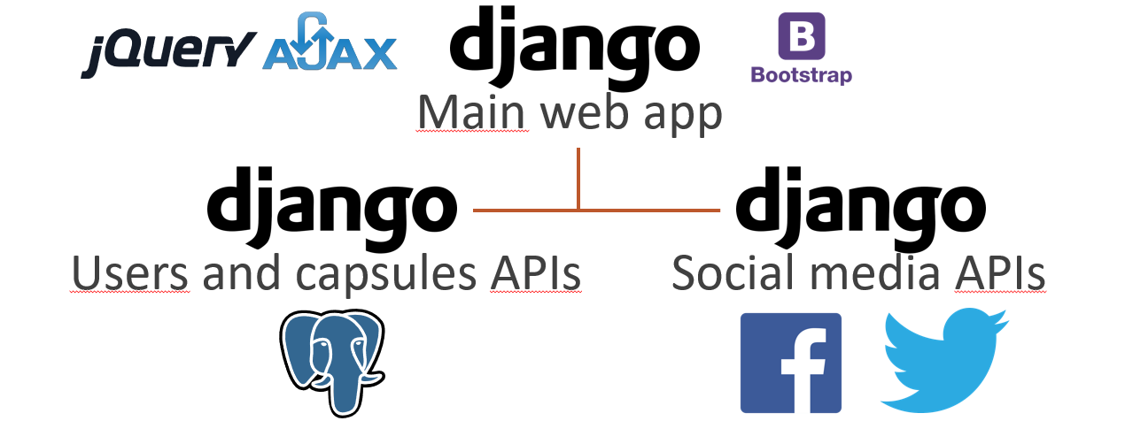

System architecture

# Application Lifecycle Management

One of our main goals when approaching the life cycle management of our applications is to try and centralize all the aspects related to this management in the fewer number of tools. We will be using GitHub, which gives us the tools required in lots of the processes related to the management.

GitHub will be used for the following tasks:

* Development planning: For each sprint, a Kanban board will be created, showing the tasks that we must work on during the sprint, its deadlines and whose responsibility will be to finish each task.
* Source code management: By using a git repository, we can guarantee an appropriate version control. Our repository will have the following workflow: A master branch with all the source code of our application that will be deployed, a development/integration branch created from this master branch whose function is to integrate and test all the code written by the developers, and branches born from this develop branch which will be related to the different use cases and functionalities that we will be working on.
* Knowledge management: All the documentation related to our project will also be uploaded to the repository. Besides, the repository’s wiki will be the place where all the members will add any kind of information that may be considered relevant for other members when working on the project.

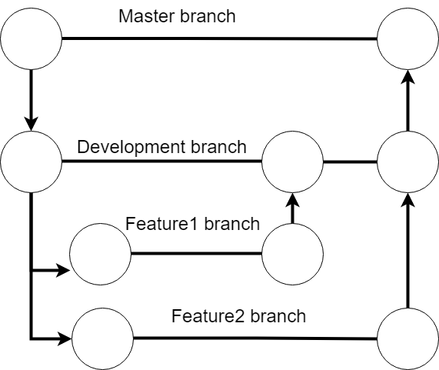

Repository workflow

Because we need to be able to have available at any point in time the state of our project after each sprint, we have decided to tag our releases in GitHub in order to access to the contents of our repository at a certain point in time. In the last commit before each delivery, we will create a tag following this structure: Release X, being X the number of the delivery that has been worked on. Each one of these releases will be independently deployed on our hosting.

There are other tools besides GitHub that will be used, such as Travis CI. Travis CI will be used in order to implement continuous integration and quality assurance in our code. Each time changes are made in our branches, before committing the code, the application will be launched using Travis and some tests will be triggered in order to guarantee the changes made work as intended and do not interfere with other features.

In order to guarantee that our product meets the expected quality standards, several tests will be designed and automated by using Travis, as mentioned before. These tests include:

* Functional tests
* Integration tests.
* Performance and scalability tests
* Code coverage tests

Acceptance and usability tests will also take place, with some pilot users that have volunteered to test our application.

To measure the efficiency of our team and the time dedicated to each task, we will be using Toggl, which will provide us with detailed reports at the end of each week. Thanks to these reports, we will be able to determine which members are working efficiently and how close to the estimated time for completing each task we are. In case we notice there are some members way more efficient than others, we may decide to shift more workload onto them, as long as there everyone in the development team agrees with that decision.

Lastly, as means of communication within the development team, we will be using Telegram to send messages to the rest of the group and Google Hangouts when in need of having online meetings.

Our full-fledged product will be hosted using Amazon Web Services. However, during our development, the prototypes will be deployed using Heroku, as it is easy to connect with our repository using Travis CI, and because these are prototypes only intended for receiving feedback, its free tier gets the job done. Using Travis CI, whenever the master branch of our repository is updated, these new changes will be automatically deployed into our Heroku prototype.

# Viability study

Our team made a survey in order to gauge interest in our application. We received 30 answers to the following questions:

Do you know what a time capsule is?

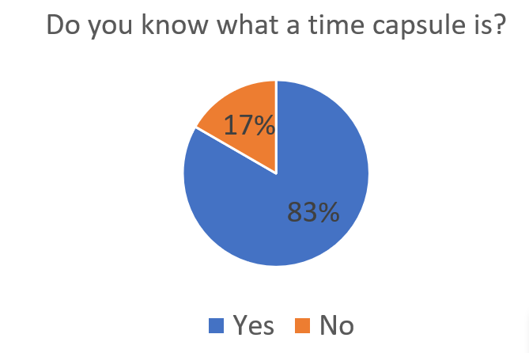

What is your age?

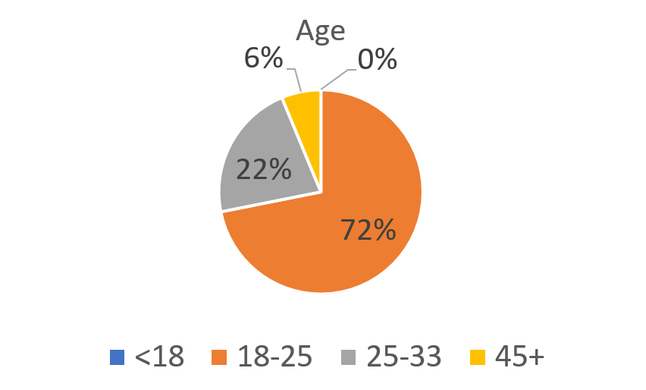

Are you interested in our idea?

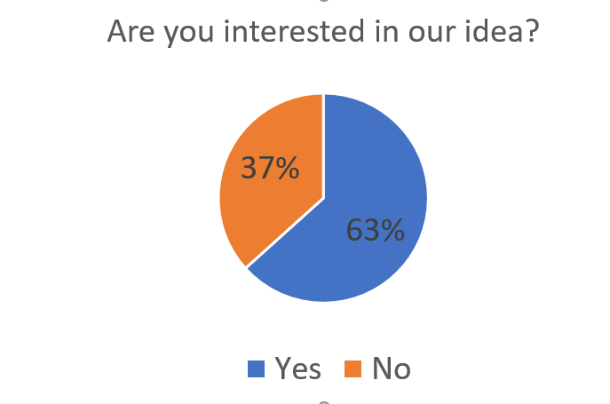

How much would you pay yearly for our services?

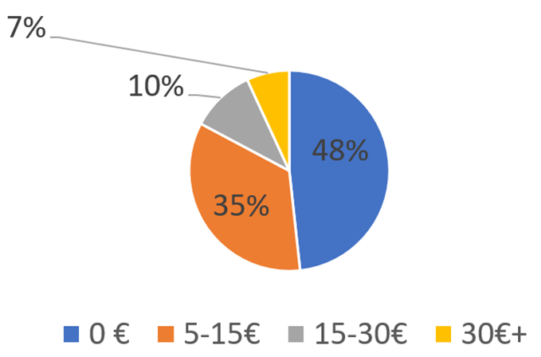

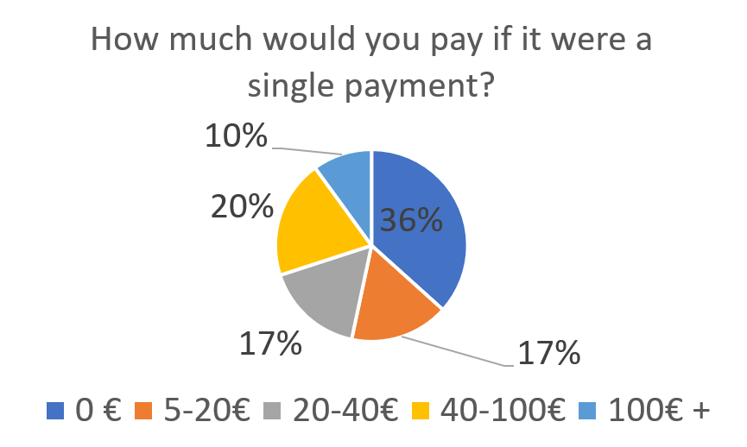How much would you pay for our services if it were a single payment?



The conclusions we have drawn from this survey are the following:

* Most of the people who answered know what a time capsule is. This benefits us, as it makes easier to explain what our product is about.
* Most of the people are also interested in our business idea.
* It is also worth mentioning that almost all the people who answered our survey were quite young. This could mean that one of our primary targets could be young people who spend a lot of the time on social networks and have lots of online contacts, but these results could also be influenced by the fact that the majority of the people who saw our survey were quite young, regardless of whether they were interested or not. In any case, we that our main target demography is comprised of young or middle age people. The reason why we reached this conclusion, besides the data obtained through this survey, is that even if young people may not think about leaving a memento in case they pass away because of how far-fetched that possibility seems to them, they are the ones with most online acquaintances they may be interested to share their memories with in the future. On the other hand, middle aged people are also used to the internet and digital media, but they also may have their own family and children, more memories and life experiences to share and think more frequently about long-term scenarios, which may motivate them to leave a message behind for the people who are close to them. While it is true that elderly people may be more interested in the features related to the creation of a time capsule that works as an online last will of sorts, they may be reluctant to use our services due to not being familiar with the Internet.
* When it comes to how much people would be willing to pay, one thing is clear: There are people who would not pay a yearly fee but would pay for our product if it were a single payment. This means that if we wanted to maximize our sales, a single payment model would be the way to go, but we must take into account the fact that a subscription model will generate more long-term profit.

# Pilot users

We reached out to those who already answered to our previous survey and asked them if they were willing to help us test our product. Only 7 of them accepted this proposal:

* Francisco Rebollo, age 55.
* Javier Álvarez, age 19.
* Valentin Alexandre, age 19.
* Antonio Gámez, age 26.
* José Manuel Juan, age 21.
* Sandra Cantón, age 28.
* José Manuel Díaz, age 21.

These are the users who are already fully committed to test the application, but this does not mean that our list is closed. We shall search more pilot users while devising our piloting plan, especially middle-aged users, as they are one of our target demographics but they are severely underrepresented in our list of pilot users.

The pilot users have explicitly accepted the following commitment: For each sprint of our development, they will test the version of the application we will provide them with along with instructions on what they must do in order to test it, and afterwards, they will submit a form where they talk about their user experience, what did they like and what did they dislike, suggestions on how to improve the prototype and whether or not they would use the final version of our product. In return, they will be able to use our services totally free of charge should our product be fully released to the market.

# Competitors analysis

We did a market research in order to determine which existing online services our product will be competing with, which are their main features and what makes our product different from them. We found 4 other similar services. The results of comparing them to our product are the following:

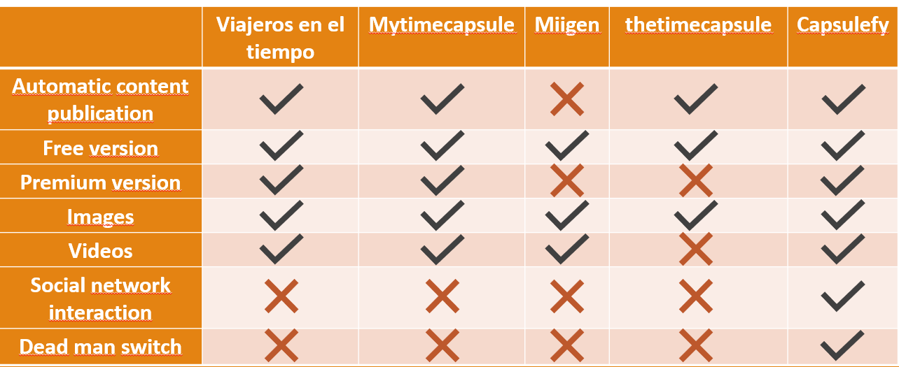

We reached the conclusion that we are treading into an already existing market, but an undeveloped one, where we can offer features that makes us distinct from our competitors, such as the interaction with social networks and the publication of content in case the user has not logged in for a very long time.

There are other indirect competitors, such as official last wills or more traditional methods of sharing memories like photo albums, but they won’t be able to offer the possibility of quickly sharing their contents online.

# Innovation

As mentioned before, there are two keys features in our services that makes us different from the rest of options and that will make us stand above them: The dead man switch and social network interaction. While the development of these features does not imply that we are innovating from a technological viewpoint, since we will be using already existing technologies (OAuth, API calls…), the way we are incorporating them into our business model is something new that has not been tried by our more direct competitors. Thanks to these features, our service is highly customizable so that every user can tailor their time capsules to their needs.

# SWOT ANALYSIS

## Strengths

* None of our competitors has capsules that will automatically be released in case of decease.
* Our application is much more complete and with more features than the already existing options.
* Highly customizable capsules.
* Free version available in which may attract potential customers after trying it.

## Weaknesses

* We have just arrived to this market niche and need to make ourselves known.
* People who already have written a last will may find our product unnecessary.

## Opportunities

* None of the existing applications has a total monopoly over the market, this means we can earn ourselves a position among the existing alternative and try to reach the top.
* There is the possibility of cooperating with insurance companies. The idea is to strike a deal with them so they can offer our services to their clients who acquire a life insurance. The users will be able to create a premium capsule in our site and the insurance companies will be charged for it. In order to make this deal more attractive, we may give these companies a special pricing, and their clients will have no date of expiration in their capsules.

## Threats

* One of our competitors may improve our application and gain a bigger share of the market before ours is ready to be released. A new competitor may also appear with similar key features as us.
* Lack of trust from our possible customers, mainly due to two reasons: Not understanding what our product is about and not having guarantees that if our business closes down, the capsules they have paid for won’t disappear.
* In order to mitigate these threats, we will need to invest in advertising so that people will see us as the best option when it comes to time capsules and will be well informed about what our business is about. On the other hand, we must find a way to assure our potential clients that they will get what they paid for regardless to what happens to our business, and worst-case scenario, assuring that they will get a full refund in case our servers shut down.

# Cost estimation

Our team has come up with 4 different cost estimations: A pessimistic one, an optimistic one, and two realistic estimations. These estimations cover costs during the development of our product, whose duration will be of 4 months, and some funds which may be used in order to deal with the risks that appear during the development or to cover initial server and advertisement costs. The factors that will affect our budget are the following:

* Team members’ salaries.
* Hardware amortization.
* Advertising funds for the first 6 months.
* Storage and hosting funds for the first year.
* Risk prevention funds.
* Taxes.

Because we will be using Amazon Web Services to store all the files our users will upload to our system, we need to take into account the individual cost per user. By using Amazon S3, we will be charged 0.024 USD per GB per month.

Assuming we will be offering 500mb of storage in each of our Premium/Modular capsules, the cost of maintaining each 500mb capsule yearly is 0.144 USD (0.127€).

Assuming free users have 20 mb of storage, the yearly cost of maintaining a free user will be of 0.0144 USD (0.0127€).

In order to decide our storage and hosting funds, we will consider the cost of maintaining 2,000 premium capsules and 20,000 free users for a year, as well as an estimation of the cost of hosting our website and our database.

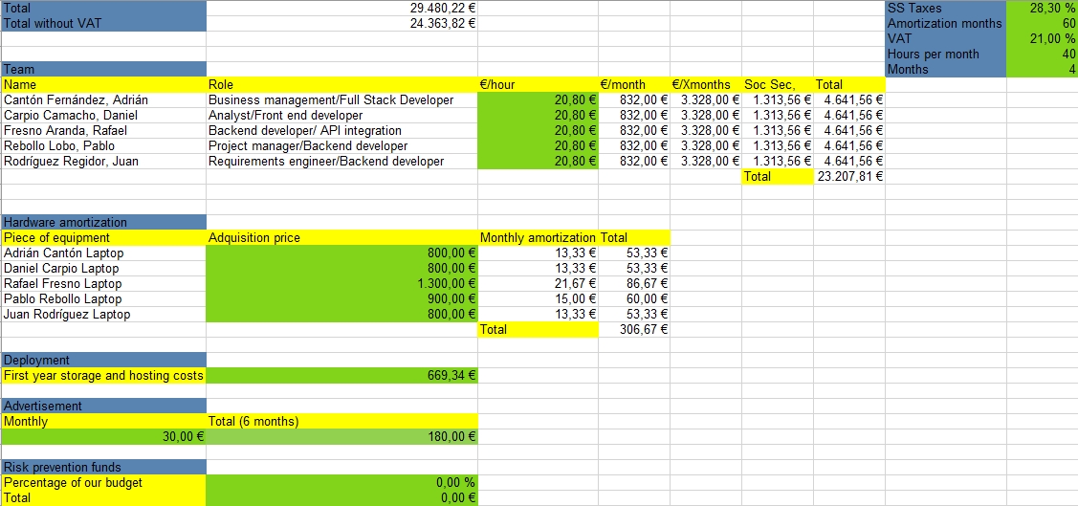

Optimistic estimation

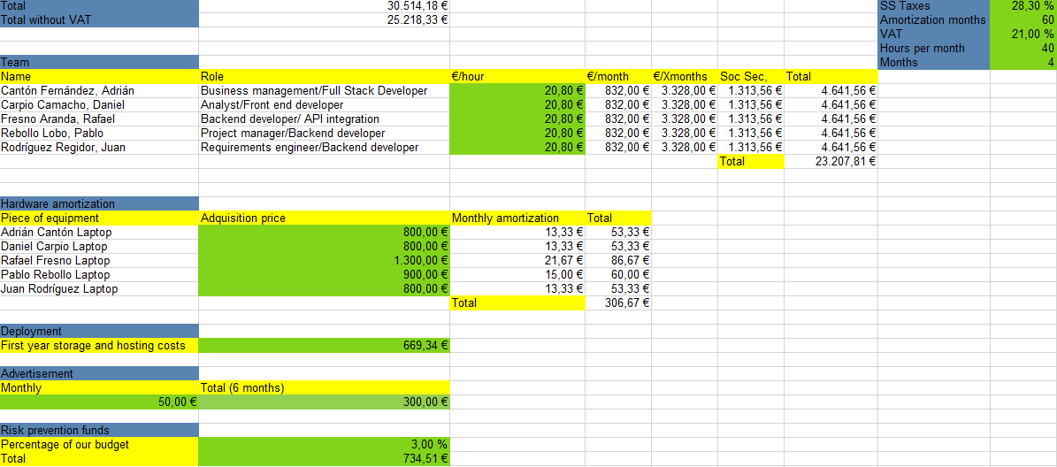

Realistic estimation 1

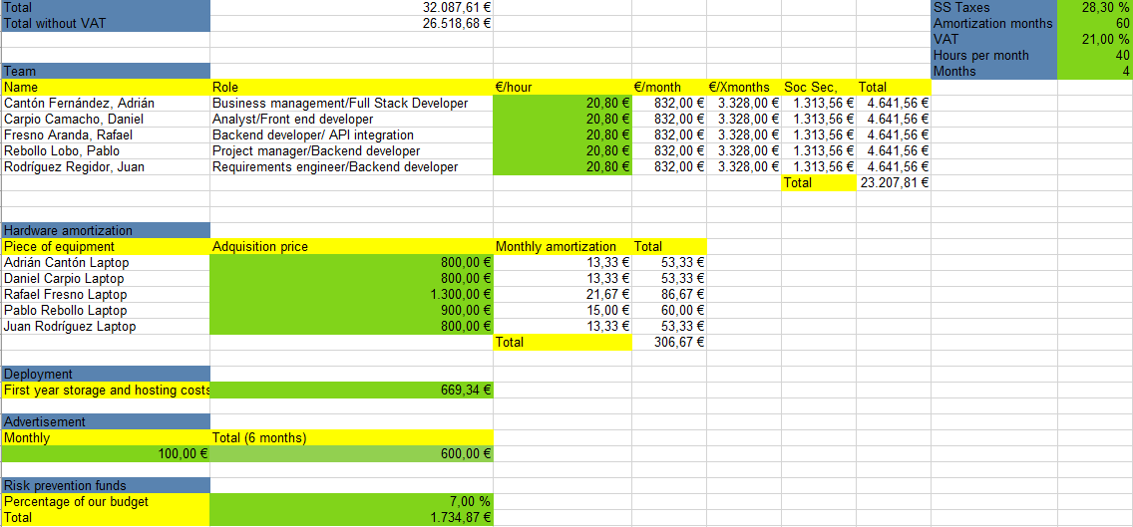

Realistic estimation 2

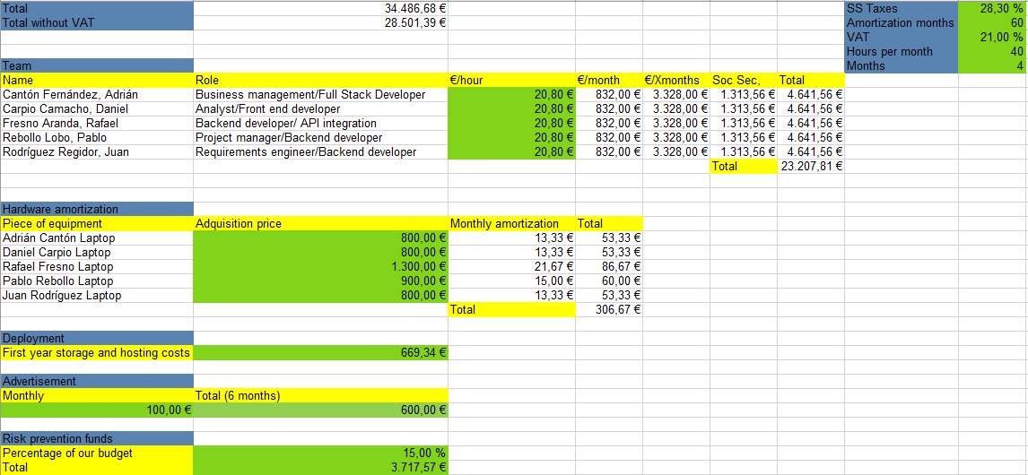

Pessimistic estimation

After doing this analysis, we reached the conclusion that our budget will be approximately between 30,000€-35,000€

# Risk analysis

There are some factors that will influence on how close the real costs of developing our product are to our optimistic or pessimistic estimation. In order to minimize the impact of these risks in our development, we must come up with some measures:

* We will be using Amazon Web Services in order to store our data. Because no member of our development team has had any previous experience with this service, there is the possibility of it taking too long to learn how to use it properly. In order to minimize this risk, one of the members of the team will be focused on how to work with Amazon Web Services and will be the one in charge to explain to the rest of the team what to do should they need to directly interact with this service. If it ends up being impossible to work with it, we must be ready to jump to other similar service, such as Azure.
* When trying to publish automated Facebook messages, because apparently is necessary to be registered as a developer in order to use its API, pilot users may not be able to try this feature if we end up needing them to use the Facebook API to schedule posts. As alternatives, we may either look for a workaround without consuming Facebook API or look for other social networks that may work as a substitute.
* We may be underestimating the scope of our MVP, which means that it will take longer to implement than expected. The team will have to try to be more efficient and if possible, rethink our planification at the beginning of each sprint.
* Changes in the requirements due to feedback from the pilot users. In this case, we will need to quickly change the planification of our sprints.
* A member of the developing team may drop out for multiple reasons. In this case, we will to reassign tasks. In order to avoid spending extra time when learning about the features said member was working on, it is recommended the code is well structured and documented, and members are encouraged to write a development diary in the repository’s wiki.
* A change in the terms of use f one of the services we interact with may force us to redesign certain aspects of our application. In order to mitigate the impact of these changes, we should be periodically monitoring these services so we can notice these changes as soon as possible and therefore, have more room to react.
* Lack of interest from our pilot users may result in a feedback which is not useful at all. To solve this problem, we should be constantly paying attention to our pilot users and whether or not they are fulfilling their obligations.

# Pricing

Each registered user will be able to create free capsules and upload files to them up to a maximum of 20mb in total. These capsules can be scheduled up to one year in the future and will be deleted 6 months after their release.

Premium and modular capsules will cost 11.99 € each, can store up to 500mb of files and will not have a limit on how far into the future they can be scheduled, nor will they disappear after being released.

# Profit estimation

We have made a profit estimation of the three first years of our service, using as reference our first realistic cost estimation. Expecting an exponential growth, we estimate we will sell about 2,000 capsules during our first year, 4,000 during our second year and 8,000 during our third year, making a total of 12,000 over three years at 11.99€ each unit, which nets us a profit of 9.9€ per sale. Our budget already includes the hosting and storage services for the first year, but we must take into account the costs for the following years, which will increase as more time capsules are created, as well as the salary of someone in charge of the maintenance of our service.

Our estimation foresees a net loss of 10,714€ during the first year, reaching the point of stability during the second year and ending it with a positive balance of 15,726€

Gains dramatically increase during the third year, reaching an accumulated profit of 80,903€ across these three years.

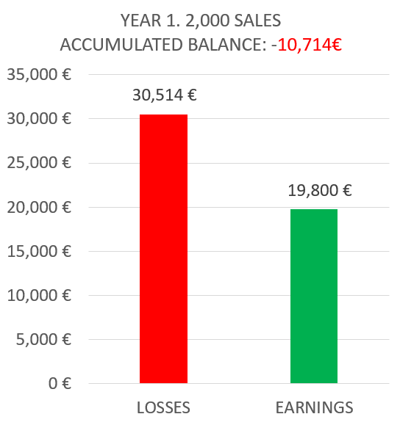

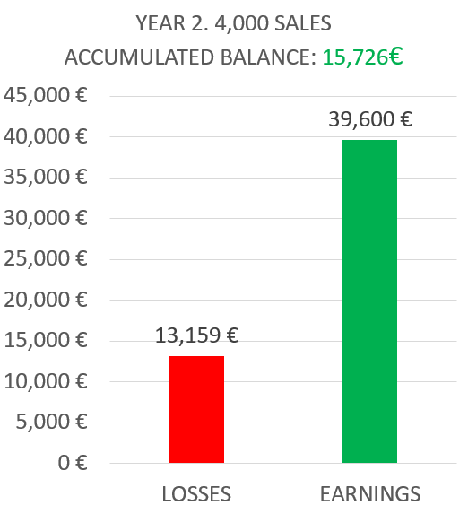

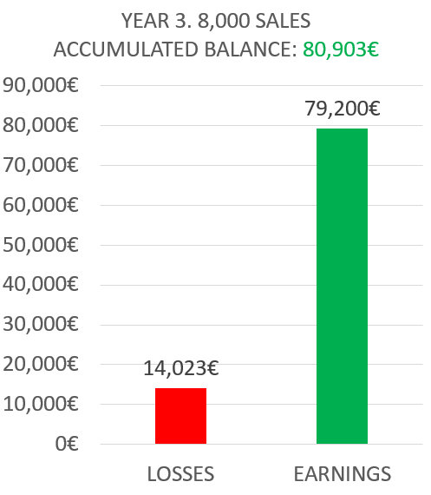

# Conclusions

Our team is very excited with this new business prospect, and we think it may be a very profitable opportunity should everything go smoothly. While it is true that our idea may not be very conventional and that one of our biggest challenges will be creating a need in our potential customers, we think about this as a long-time investment which eventually will grow into a stable business.